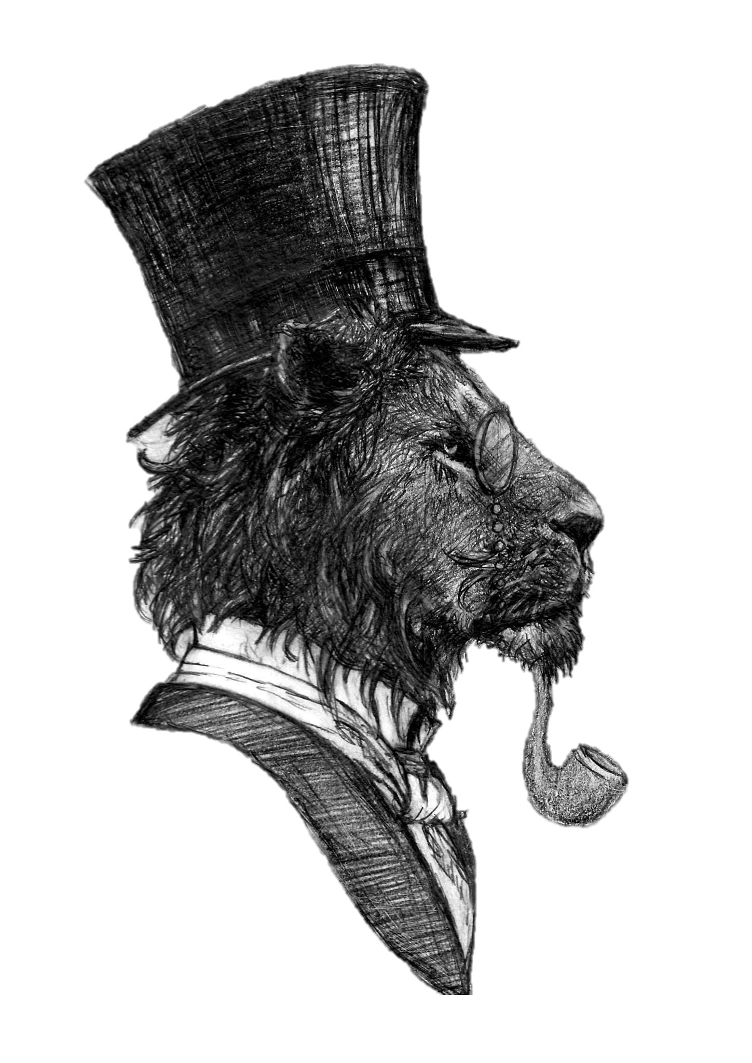
The Lyon Inn
A La Carte Menu

Nibbles while you Wait?
Bread, Balsamic & Olives £4.95 (VE/V)
Salted Pig & Apple £4.50
Hoisin Duck & Plum £4.50
Rhubarb & Ginger Fizz £6.95 (VE)
Espresso Martini £8.00 (VE)
Starters
Smoked Duck, Beetroot Jam & Ginger Gel £7.50
Cod Cheek Fritters, Tartare Sauce, Burnt Lemon £7.95
Lyon Pork Pate, Sourdough, Rum & Apple Jam £7.95
Spring Salad, Beetroot, Radish & Crouton £7.00 (VE)
Cauliflower 3 Ways, Asparagus & Honey Mustard £7.00 (VE)

Mains
Pork Belly, Black Pudding, Vanilla Apple & Sage, Bacon Potato, Steamed Spring Veg & Cold River Cider Jus £19.00
Lamb, Balsamic Onions, Minted Peas, Apricot Rosti & Red Wine Reduction £21.00
Charred Saffron Chicken, Pomegranate Cous Cous, Hand Picked Leaves & Honey, Lemon & Coriander Sauce £19.00
Wild Mushroom Risotto with Vegan Parmesan £17.50 (VE)
Grilled Swordfish, Monksbeard, White Wine Cream, New Potatoes & Charred Veg £25.00

From the Grill*
10 oz Hereford Rib-Eye £24.00
14 oz Longhorn Sirloin served on the Bone £35.00
8 oz Fillet £32.50
Served with Lyon Grill Garnish, Red Wine Jus & your choice of Chips & Peas or Dauphinois Potatoes & Seasonal Veg

The Lyon Grazing Bowl
A base salad of rice, monks beard & hand-picked leaves – choose 2 from the following:
Avocado (VE)/ Sword Fish (P)/ Crispy Vegetables (VE)/ Crispy Beef
Saffron Chicken / Crispy Pork
£19.00

Puddings
Cherry Cheesecake, Kirsch, Cherry Glace £7.50
Strawberry & Cream Assiette Macaron, Meringue, Marshmallow £7.50
Gloucester Apple Dessert £6.95
Chocolate & Raspberry Mousse with Chocolate Milkshake Shot £6.95
Ice Cream Selection £5.00
To Finish
Tea/Coffee from £2.60
Cheese Board £10.00
Add Port for £2.00
Houle Digestif £3.00
Limoncello Digestif £3.00
Dessert Wine £6.75
Liqueur Coffee £4.95

