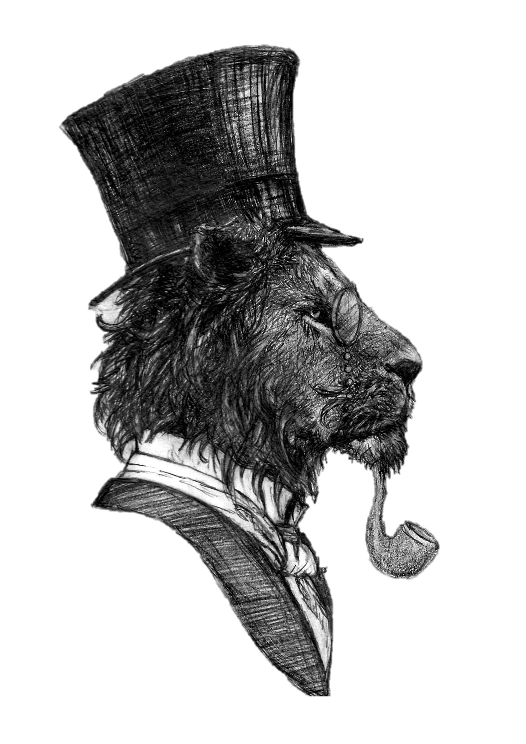
The Lyon Inn
Bar & Garden Daytime Menu

Starters
Soup of the Day, Bread & Netherend Butter £4.50 (VE)
Chicken Wings, Salad & Dipping Sauce £5.25
Severn & Wye Fish Platter, Tartare Sauce & Burnt Lemon – The Perfect Sharer £17.50
Crispy Beef served on a Bed of Rice £5.25

Mains
Grilled Gammon with Pineapple & Egg, Home Cooked Chips & Peas £12.50
Traditional Faggots, Mash, Mushy Peas & Gravy £9.50
Rib Eye Steak, Lyon Grill Garnish, Chips & Peas £24.00
Roasted Vegetable Pasta in a White Wine Cream Sauce with Salad & Garlic Slice £16.50 (VE)
Pie of the Day with Home Cooked Chips, Peas & Gravy (minimum 45-minute wait) £12.95
Cod & Chips with Mushy Peas £12.25
Lyon Burger (choose from Beef, Lamb, Chicken, Halloumi or Vegan) with Chips & Salad £12.50
Ploughman’s – choose from cheese, ham or both £10.50
Afternoon Tea £15 or £25 for Two

Light Bites
Sandwich with Chips or Crisps – choose from: Cheese & Onion / Beef / Turkey / Ham /
Tuna Mayonnaise / Egg Mayonnaise Coronation Chicken £9.95
Hot Panini with Chips or Crisps – choose from: BBQ Chicken / Tuna Melt / Ham, Tomato & Cheese /
Cheese Melt / Vegan Cheese & Onion Melt £9.95
Pizza – choose from: Margherita / Meat Feast / Goats Cheese & Caramelised Onion / Hawaiian /
Pepperoni/ Pulled Pork £12.50

Sides
Home Cooked Chips £2.95
Halloumi Fries £3.23
Garlic Bread £2.25
Cheesy Garlic Bread £3.25
Cheesy Chips £3.95
Onion Rings £2.25

Puddings
Cheesecake (Ask for Today’s Flavour) £5.95
Strawberry & Cream Assiette Macaron, Meringue, Marshmallow £7.50
Gloucester Apple Dessert £6.95
Ice Cream Selection £5.00
Cheese Board £10.00

