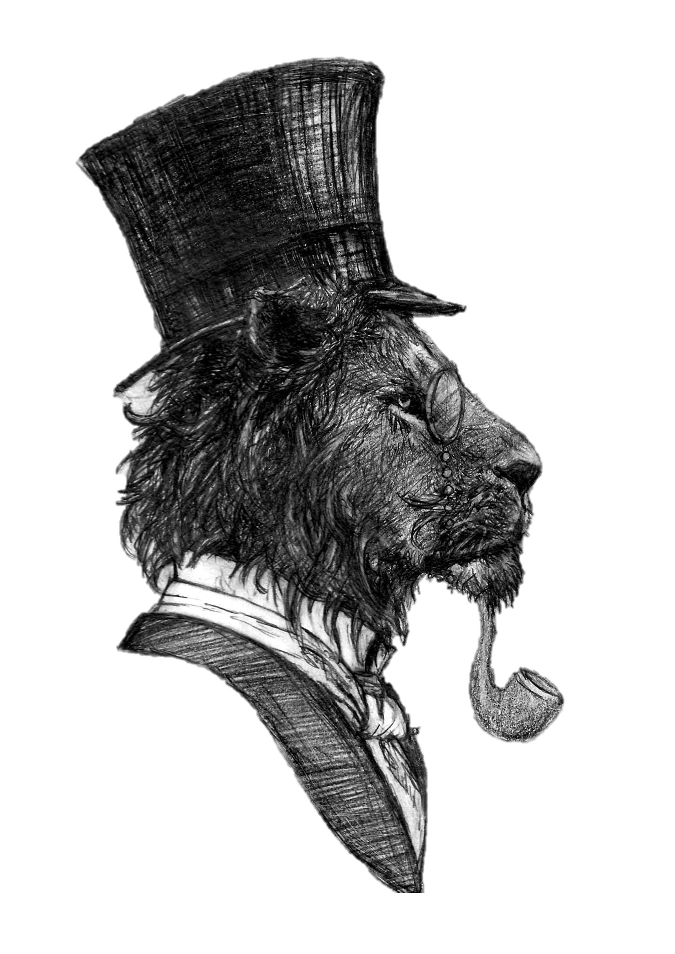
The Lyon Inn
Bar & Garden Evening Menu

Nibbles while you Wait?
Bread, Balsamic & Olives £4.95 (VE)
Garlic Bread (VE)
Cheesy Garlic Bread
Starters
Soup of the Day, Bread & Netherend Butter £4.50
Chicken Wings, Salad & Dipping Sauce £5.25
Lyon Pork Pate, Sourdough, Rum & Apple Jam £7.95

Mains
Pork Belly, Black Pudding, Vanilla Apple & Sage, Bacon Potato, Steamed Spring Veg & Cold River Cider Jus £19.00
Charred Saffron Chicken, Pomegranate Cous Cous, Hand Picked Leaves & Honey, Lemon & Coriander Sauce £19.00
Wild Mushroom Risotto with Vegan Parmesan £17.50 (VE)

From the Grill*
10 oz Hereford Rib-Eye £24.00
Served with Lyon Grill Garnish, Red Wine Jus & your choice of Chips & Peas or Dauphinois Potatoes & Seasonal Veg

Sides
Home Cooked Chips £2.95
Halloumi Fries £3.23
Cheesy Chips £3.95
Onion Rings £2.25

Puddings
Cherry Cheesecake, Kirsch, Cherry Glace £7.50
Strawberry & Cream Assiette Macaron, Meringue, Marshmallow £7.50
Gloucester Apple Dessert £6.95
Ice Cream Selection £5.00
Cheese Board £10.00
Add Port for £2.00
To Finish
To Finish
Tea Selection £2.60
Coffee Selection from £2.60
Houle Digestif £3.00
Limoncello Digestif £3.00
Dessert Wine £6.75
Liqueur Coffee £4.95
Espresso Martini £8.00

