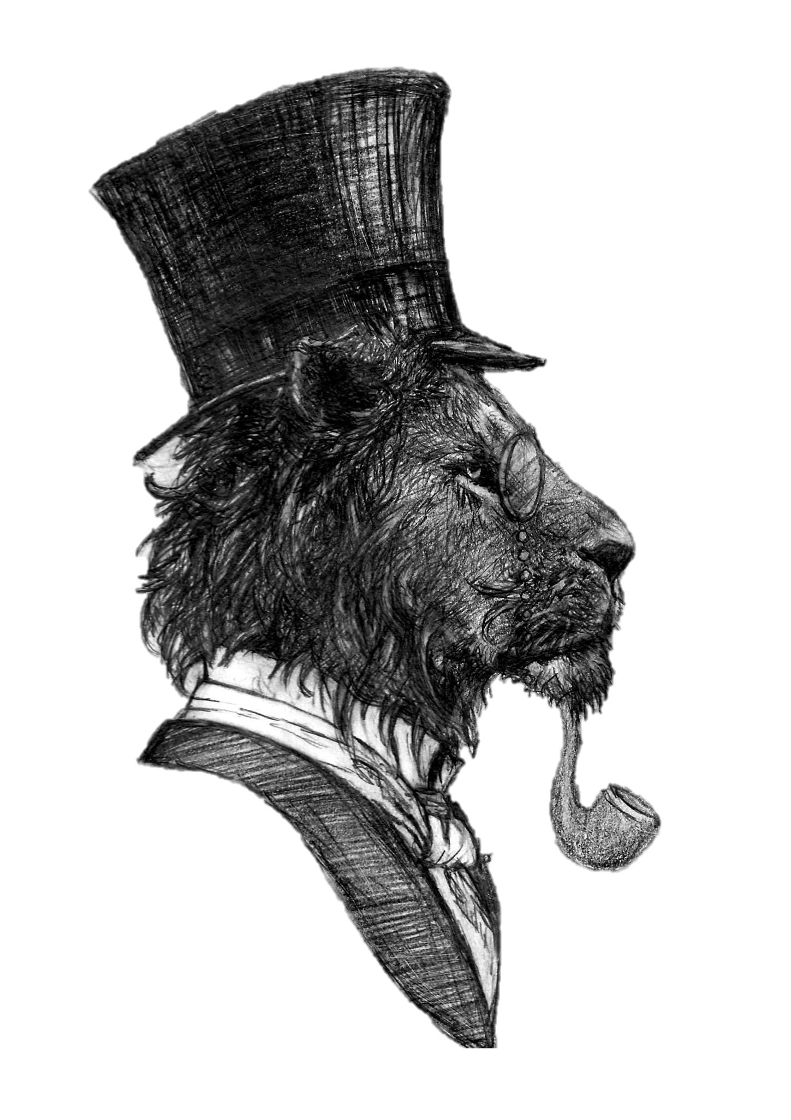
The Lyon Inn
Sunday Lunch Menu

Nibbles while you Wait?
Bread, Balsamic & Olives £4.95 (VE)
Garlic Bread (VE) £2.25
Cheesy Garlic Bread £3.25
Rhubarb & Ginger Fizz £6.95
Starters
Soup of the Day, Bread & Netherend Butter £6.00
Cod Cheek Fritter, Tartare Sauce, Burnt Lemon £6.00
Chicken Liver Pate, Bread & Onion Jam £6.00
Cauliflower 3 Ways, Asparagus & Honey Mustard £6.00

Mains
Slow Roasted Topside with Traditional Yorkshire Pudding £14.00
Roast Pork & Stuffing with Yorkshire Pudding £14.00
Caramelised Onion & Goats Cheese Tart £14.00

All main courses are served with seasonal vegetables, mashed potatoes & roast potatoes. Children are provided with a half portion of any of the above.

Puddings
Fresh Cheesecake (Ask for Today’s Flavour) £5.95
Syrup Sponge with cream, ice cream or custard £
Sticky Toffee Pudding with cream, custard or ice cream £
Chocolate sponge with cream, custard or ice cream £
Fresh cream trifle £
Cheese Board £10.00
Add Port for £2.00
To Finish
To Finish
Tea Selection £2.60
Coffee Selection from £2.60
Houle Digestif £3.00
Limoncello Digestif £3.00
Dessert Wine £6.75
Liqueur Coffee £4.95
Espresso Martini £8.00

